SW Engineering CSC648/848 Section 01 Summer 2017

Jizhou Yang- Team Lead- jyang15@mail.sfsu.edu

Rafsan Saadi- CTO

Raghav Parti

Takahiro Odaka

Brandon Yu

Zach Melamed

Team # 3

Stock Photo Marketplace

Milestone 5

8/9/2017

Document Revisions

|  |  |  |
| --- | --- | --- |
| Submission Date | Feedback given | Feedback Implemented |
| 8/9/2017 |  |  |
|  |  |  |
|  |  |  |
|  |  |  |
|  |  |  |
|  |  |  |

1. Product Summary

Name of Product: Stock Photo Marketplace

The features of Stock Photo Marketplace is listed in the following table.

|  |  |
| --- | --- |
| Feature | Description |
| Browse | Any user can browse our website and see the photos |
| Search | Any user can use the search bar and category filter to search for specific photos |
| Register | Any user can register an account on the website |
| Login | Registered users can login into their account |
| Manage | Registered users can see, edit, upload and delete the photos under his account. |
| Message | Registered users can send and receive messages from other registered users. |

Unique of our product: Message system. Registered users can send and receive message from owner to setup a deal.

The Stock Photo Marketplace can be found by following the link below:

http://sfsuse.com/~su17g03/Home

1. Milestone Documents
2. Screen shots of actual final product as show in the demo
3. Workbench screen shots of your actual DB (1-2 pages)

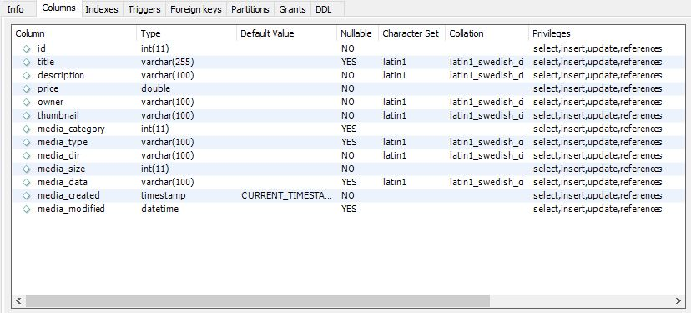  
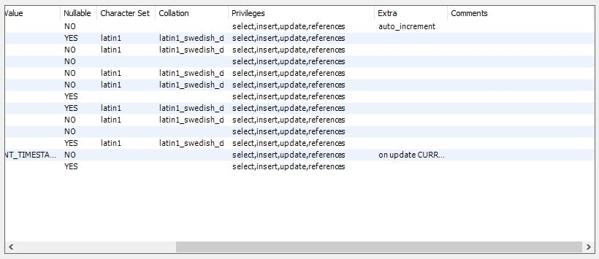  
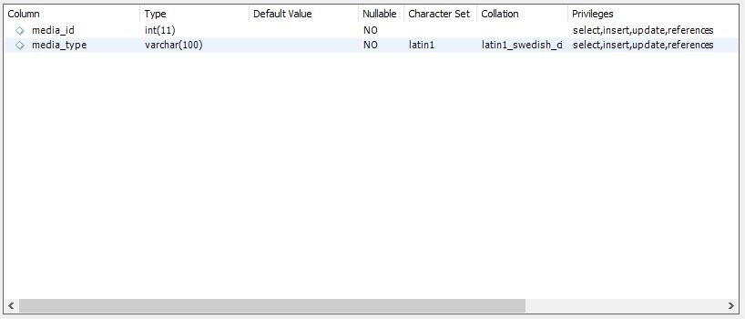

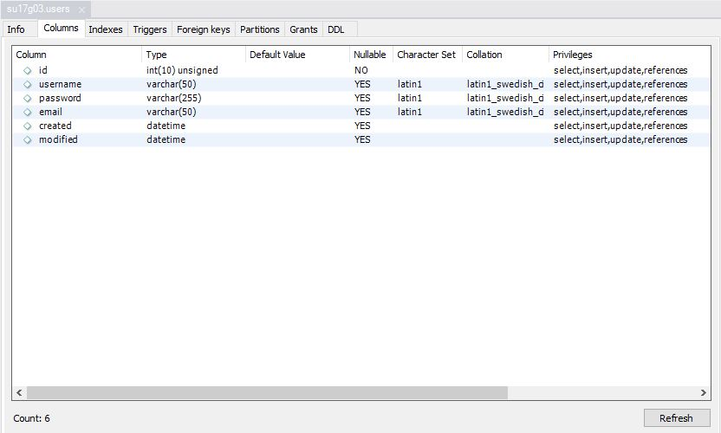

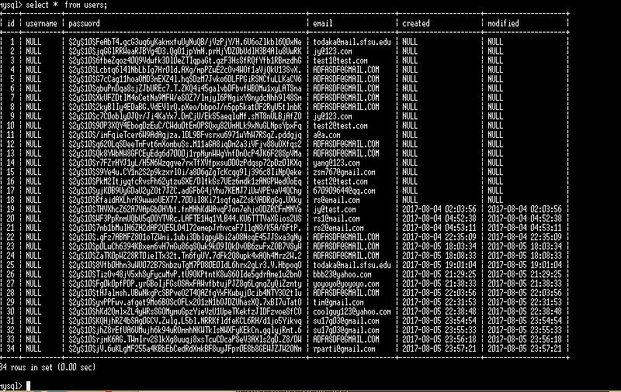

1. Google analytics plot

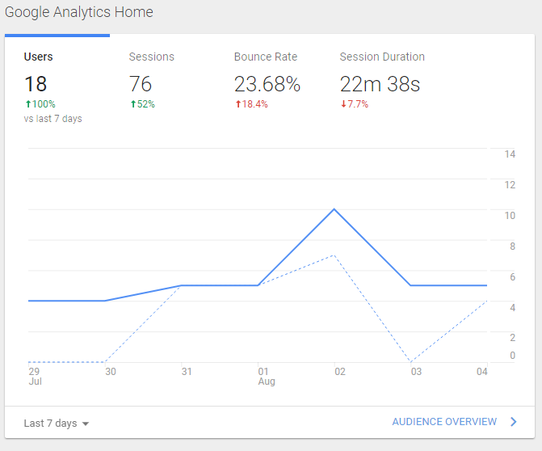

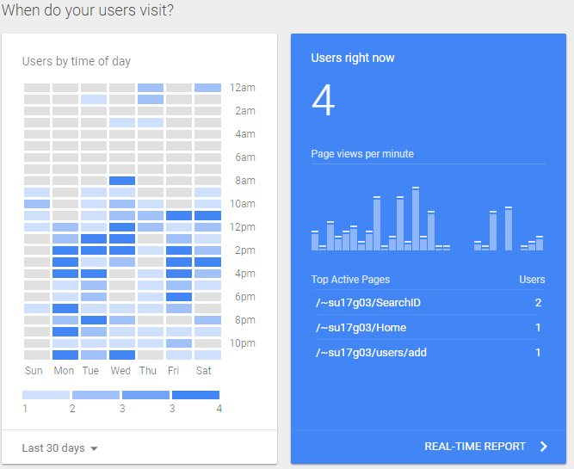

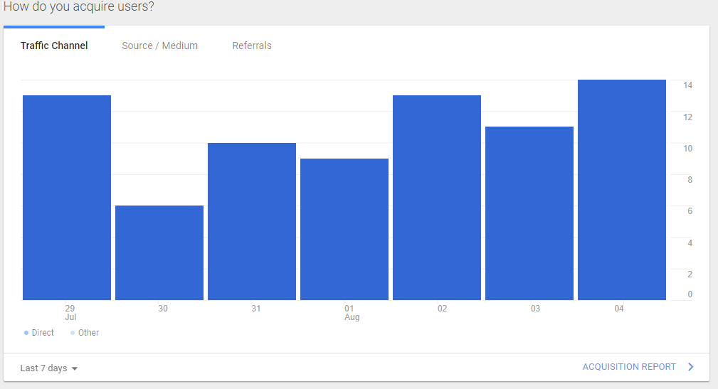

1. Team Member Contributions

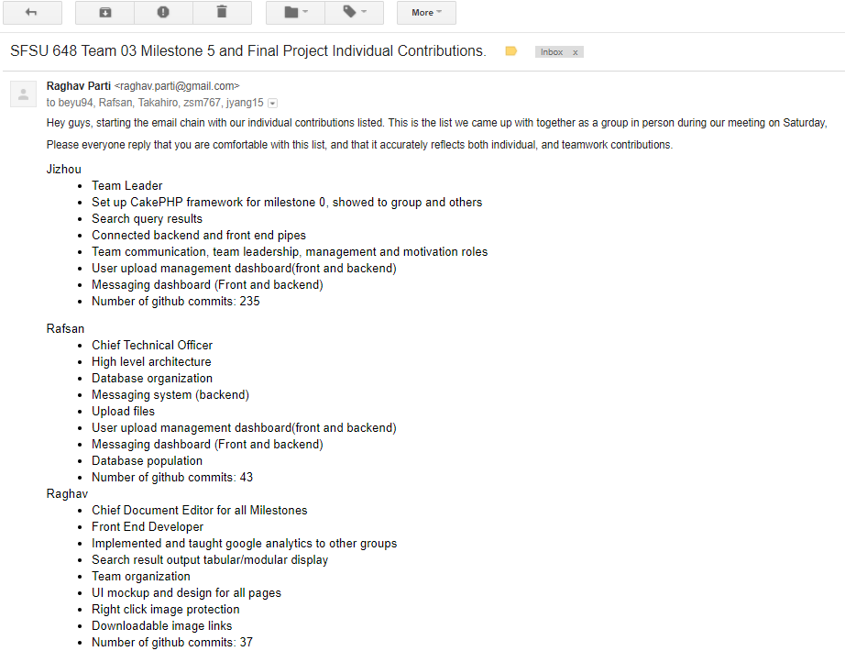

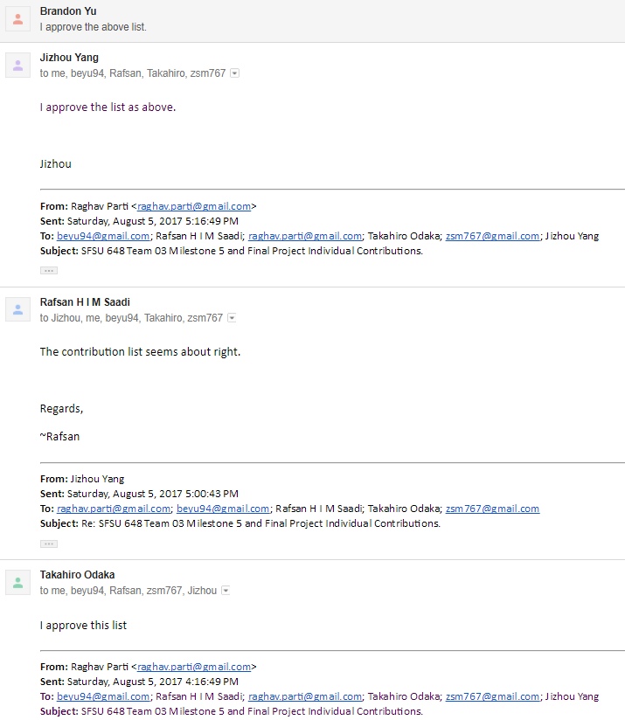

1. Team Challenges and Comments